





**Daily Insolation (DINSOL-v1.0) program**

User’s Manual

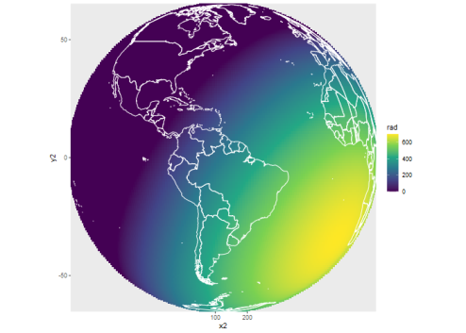

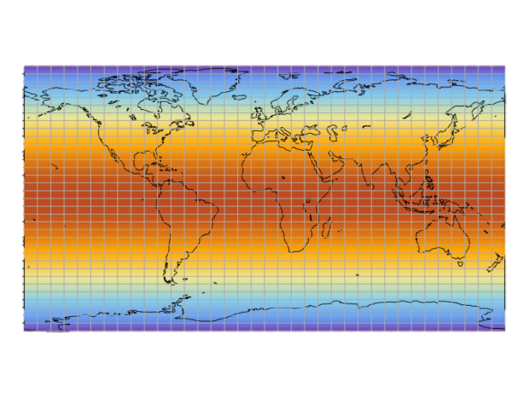

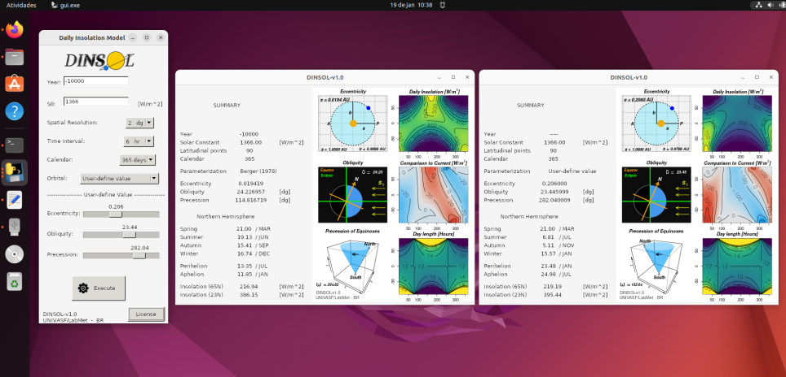

Emerson Damasceno de Oliveira

2023

*Welcome to the DINSOL*

The Daily INSOLationi (DINSOL-v1.0) is a program that simulates the incoming solar radiation at the top of the atmosphere following the Milankovitch cycles theory. The program is ideal for preparing the boundary conditions of climate models, beyond to be a helpful tool for educational purposes. The program allows the user to simulate the solar radiation data using many options, such as setting the number of points of latitude and longitude, the solar constant, a calendar of 365 or 360 days, or choosing between the most famous parameterizations to the Earth orbital parameters (EOP): Be78, Be90, and Laskar. The users can also set the EOP freely, which allows simulating the solar radiation of hypothetical cases, such as exoplanets. Moreover, by adopting the graphical user interface (GUI), the users can run the tool intuitively and generate many windows containing the results individually. The most important advantage of adopting the DINSOL is to simulate the global solar radiation, which considers the effect of the Earth's rotation on incoming solar radiation by a realistic approach. Thus, the DINSOL is a good option for students, teachers, and researchers that needs to perform some scientific study or only want to teach about solar radiation for paleoclimatology, astronomy, mathematics, or any other geoscience area.

The program was developed with the initial purpose of being just a solar radiation model that could be coupled to any climate model. However, it was found that the model would be very useful for teaching activities and helping teachers and students during climatology classes. Therefore, an intuitive graphical interface was created in PyGTK, making the execution of the DINSOL program easier. Furthermore, the DINSOL model was written in Fortran, the most widely adopted programming language in climate models. Emerson Damasceno de Oliveira, Ph.D. in Climate Sciences, wrote all the model's source code, scripts, and graphical interfaces. Oliveira works at the Laboratory of Meteorology (LabMet) at the Federal University of Vale do São Francisco (UNIVASF). The copyright of the DINSOL model is restricted to UNIVASF and Emerson D. Oliveira. However, this free software adopts a GNU General Public License (GPL), which allows the user to redistribute and modify the source code. For more details on the GPL license, visit https://www.gnu.org/licenses/licenses.html#GPL.

DINSOL was inspired by an R package called PALINSOL, created by Michel Crucifix. The numerical solution of the DINSOL model has less than a thousand lines of code, which are commented to facilitate the users' understanding. DINSOL model solutions can be easily understood and inserted into climate models. Ultimately, the model can also estimate the beginning dates of Solstices, Autumn, Perihelion, and Aphelion; these dates follow the dates provided by the PMIP, presenting an error in the order of 0.01 days.

Dear users, this manual will cover from installation to the use of the DINSOL model. This document will not describe or discuss numerical solutions adapted from other authors and developed exclusively for DINSOL.

Good luck!

**Summary**

**1 - Installation** 4

**2 - Program execution** 5

**3 - Input data** 9

**4 - Namelist** 10

**5 - Output data** 11

**6 - Some examples** 13

**References** 20

**1.0 - Installation**

This tutorial will use Ubuntu 22.04 as a Linux operational system. However, the DINSOL program can run on any Linux distribution:

After downloading and unzipping the **dinsol-v1.0_linux.zip** file, you can see the following files and folders:

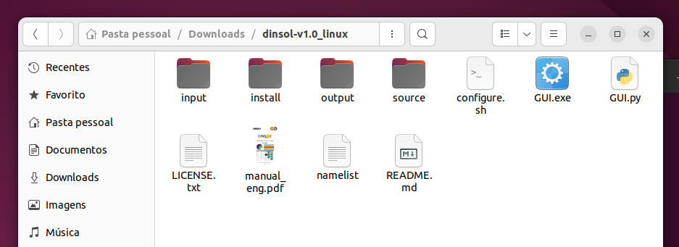

Open your Linux terminal and run the **configure.sh** file, this script will update your repository and install all the languages and packages needed to run DINSOL. When the installation is finished, the model will already be compiled and the executable file “**dinsol.exe**” will be created in the main directory of the model, as shown in the image below:



**Note 1**: The script **configure.sh** will only work on **Debian** based Linux distributions. If your Linux system is based on Arch Linux, you will need to replace the commands in the **configure.sh** file (for instance: changing “**apt install**” to “**pacman –S**”).

**Note 2**: **python-gtk2** is no longer available in Ubuntu since 20.04 LTS version. To work around this issue, the program already has a compiled graphical user interface (**GUI**) in the main folder, where to execute the DINSOL in GUI mode is necessary to use the **WINE** (Wine is not an Emulator). Thus, due to WINE being available for many Linux distributions, it is now expected that the DINSOL program can be executed on many Linux machines.

**2 – Program execution**

**COMMAND LINES**

In order to run the model by command lines, just open the terminal and go to the directory where the model is and run the file **dinsol.exe**. Furthermore, for access the model execution options, the user must open and edit the **namelist** file. Below is an image of this file:

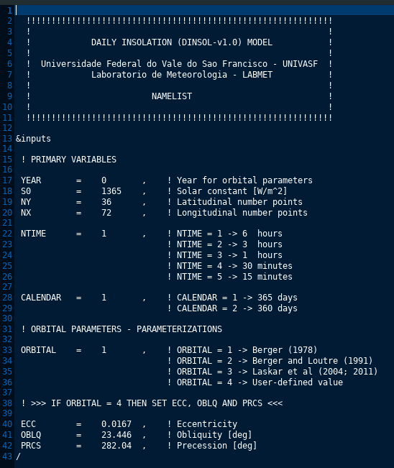

On the next page is a screenshot of the run summary provided by the model in the linux terminal.

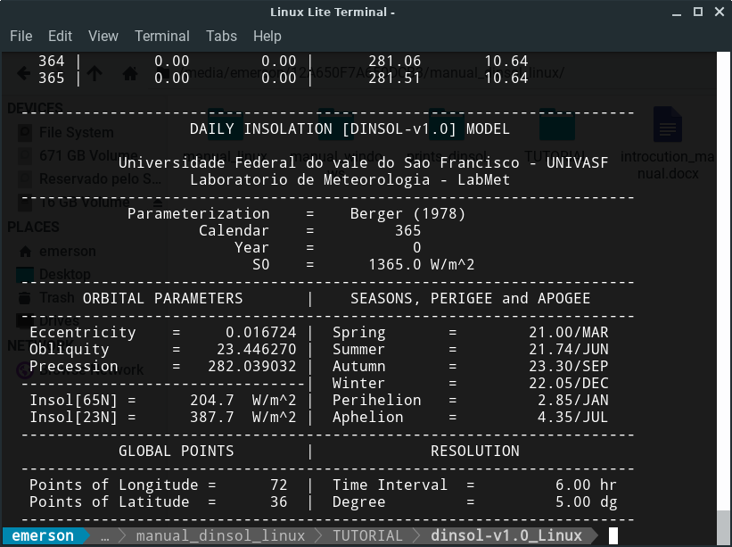

All files generated during the simulation are saved in the **output** directory, they are:

**summary.txt insolation.txt solar.radiation**  **solar.radiation.ctl**

**radiation radiation.ctl**

In the output directory are some scripts to assist the user in viewing the results with GrADS and R, for example: Daily Insolation **GrADS** (left image) and **R** (right image).

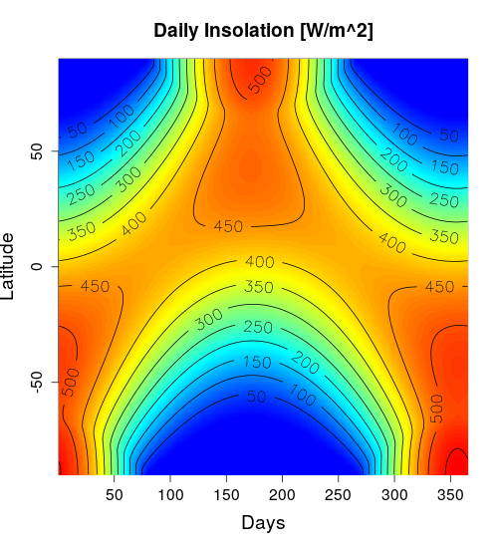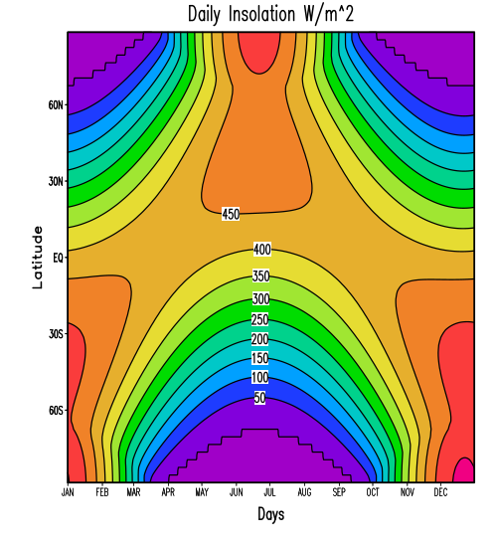

In case the user needs to analyze specifically a **day** and/or **latitude**, just edit and execute the **get_dinsol_value.R** script (use the command: **Rscript get_dinsol_value.R**). Below is a simple demonstration of the console output in R and the graphics generated with this script:

[1] " DAILY INSOLATION (DINSOL) MODEL "

[1] ""

[1] " [ Day = 178 | Latitude = -23 ]"

[1] " [ Daily Insolation ~ 262.01 W/m^2 ]"

[1] " [ Day length ~ 10.63 Hours ]"

[1] ""

An image file (png) is also created with a panel of 6 graphics, it should be noted that the accuracy depends on the adopted latitudinal resolution.

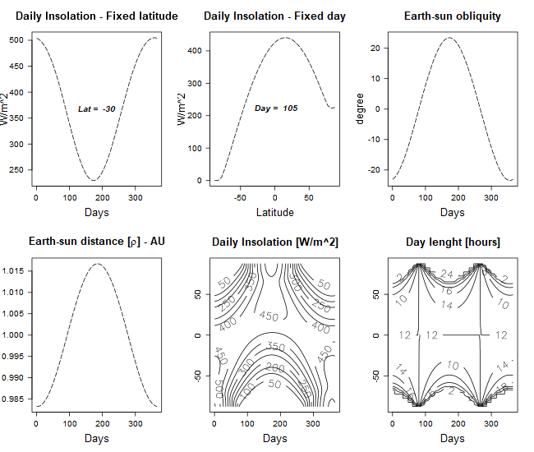

The user can still use another script (**plot_radiation.gs**) to visualize a 3D animation of the annual global solar irradiance with the GrADS.

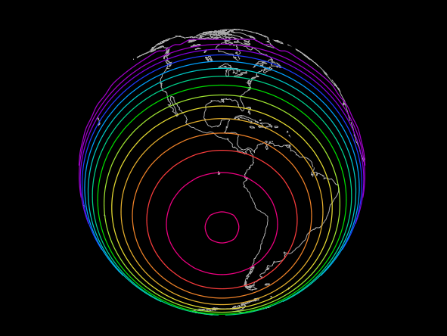

There is also the option for the user to visualize the global solar irradiance with a flat projection, just editing the desired day and hour in the **plot_global.R** script.

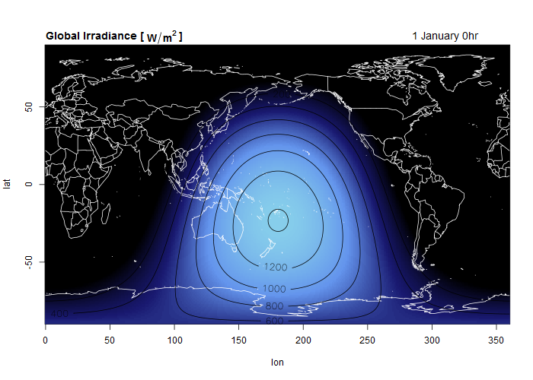

**GRAPHICAL USER INTERFACE (GUI)**

The user can open the graphical interface in the terminal with the command “**wine GUI.exe**”, the graphical mode has the advantage of offering a quick and customized view of the results of each simulation, allowing the user to open different windows at the same time.

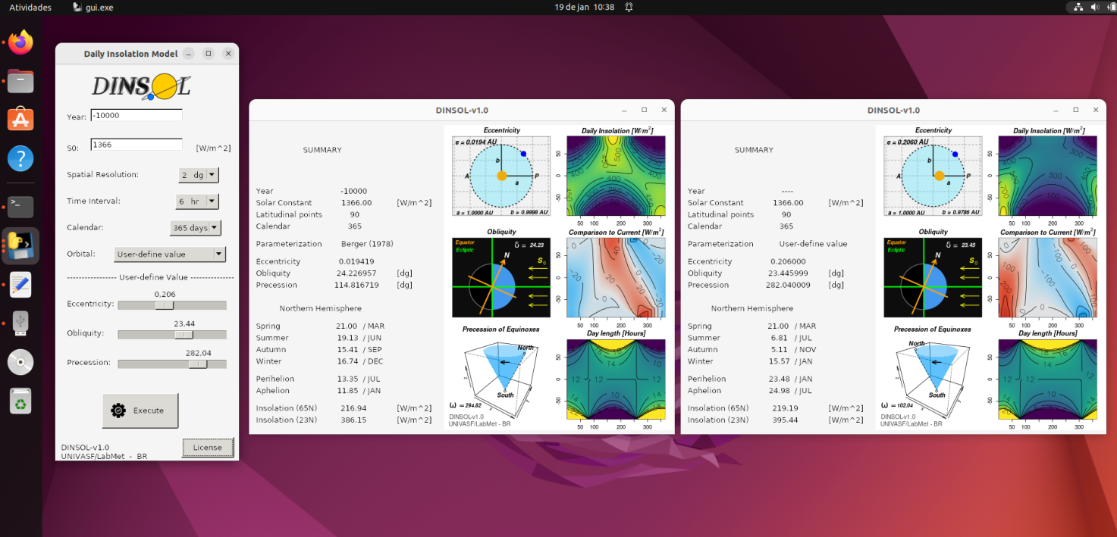

The results of the GUI mode are also in the output directory, but it should be noted that with each new simulation, the previous data is erased

**3 – Input data**

In the input directory are the data that enter the subroutines that calculate the orbital parameters. These data were obtained and adapted for DINSOL from other programs. This data can be found with the links available below, it should be noted that these data represent the years of hard work of some researchers. Therefore, when using DINSOL, remember to cite the work of these researchers, as well as the DINSOL creator.

***Université catholique de Louvain* (UCLouvain):**

[**https://www.elic.ucl.ac.be/modx/index.php?id=83**](https://www.elic.ucl.ac.be/modx/index.php?id=83)

André Berger, Michel Crucifix, Qiuzhen Yin.

***Virtual Observatory*** (**VO**) ***Paris data center***

***Institut de Mécanique Céleste et de Calcul des Éphémérides*** "(**IMCCE**)

[**http://vo.imcce.fr/insola/earth/online/earth/earth.html**](http://vo.imcce.fr/insola/earth/online/earth/earth.html)

Laskar, J; Robutel, P; Joutel, F; Gastineau, M; Correia, ACM; Levrard, B.

**4 – Namelist**

**YEAR**  - The **Year** chosen by the user can be any whole number. Note: **zero** represents the present time, which is equivalent to the year **1950 d.c** in the Berger 78 parameterization. The user can adopt any integer value for the variable **Year**, as long as it respects the range -249 through 21 [**106** **yr’s**].

**S0** - Defines the value of the Solar Constant adopted in the simulation, the default unit is

W/m². Note: S0 must be within the range ] 0:108 [

**NY** - Determines the number of **latitude points**.

**NX** - Determines the number of **longitude points**.

**NTIME** - Determines the time interval within 1 day, given in hours or minutes.

**1 – 6 hours = 0h ; 6h ; 12h ; 18h**

**2 – 3 hours = 0h ; 3h ; 6h ; 9h ; 12h; 15h ; 18h; 21h**

**3 – 1 hours = 0h ; 1h ; 2h ; 3h … 22h ; 23h**

**4 – 30 min = 0h ; 0.5h ; 1.0h ; 1.5h ; 2.0h … 23.0h ; 23.5h**

**5 – 15 min = 0h ; 0.25h ; 0.5h ; 0.75h; 1.0h … 23.5h ; 23.75h**

**CALENDAR** - Defines the number of days in the year:

**1 – 365 days**

**2 – 360 days**

**ORBITAL** - Defines the method for calculating the orbital parameters:

**1** - **Berger (1978)** is defined; accuracy of **+/- 1 x 106**.

**2** - **Berger e Loutre (1991)** is defined; accuracy of **+/- 3 x 106**.

**3** - **Laskar et al (2004; 2011)** is defined; accuracy of **-249 x 106** through **+21 x 106**.

**4** - **User-defined** is defined; the user can freely choose the values of the orbital parameters, having only to respect the valid ranges for **Eccentricity**, **Obliquity** and **General Precession**.

**ECC** - User can choose any value in the range [0:0.5]

**OBLQ** - User can choose any value in the range [-90:90], the unit of measurement is given in degrees.

**PRCS -** User can choose any value in the range [0:360[, the unit of measurement is given in degrees.

**5 – Output data**

**solar.radiation.ctl e radiation.ctl**

These are the descriptor files of the **solar.radiation** and **radiation** binary files, which can open with the GrADS. In this files is possible to see only the variable "***daily insolation***" [W/m2] (function just of day and latitude) and "***global irradiance***" [W/m2] (function of day, hour, latitude and longitude).

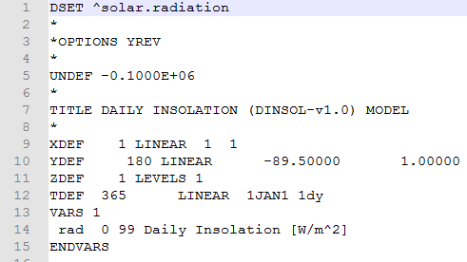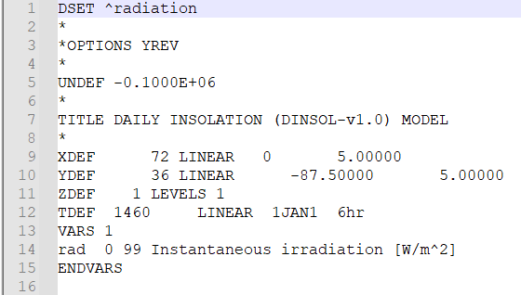

**insolation.txt**

The file “**insolation.txt**” has the variables: ***Simulation Year*** ; ***Day*** ; ***True Solar Longitude (TrueLong)*** ; ***Earth-Sun distance (Rho)*** ; ***Geographical Latitude (Lat)*** ; ***Solar declination (Decl)*** ; ***Daylight length (Sunshine)*** ; ***Daily Insolation (Insol)***.

Below is a screenshot demonstrating how data is in this file:

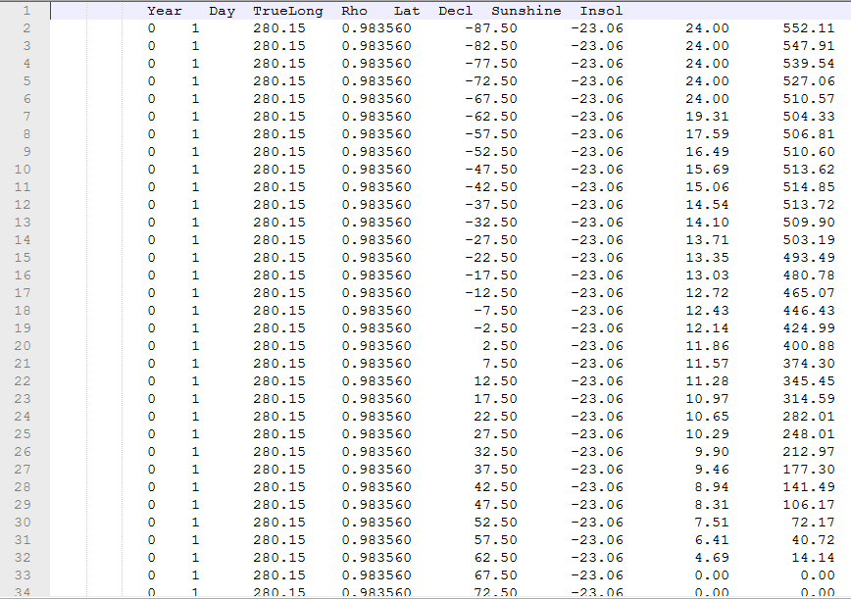

**summary.txt**

The “**summary.txt**” file is equivalent to the summary of results that appears at the end of the simulation at command line mode, or, on the graphical window in GUI mode. This file highlights the following information and variables: **year; solar constant; number points in x; number points in y; time interval; calendar; parameterization index; eccentricity; obliquity; general precession**. The dates of the seasons: **summer; autumn; winter**. The apogee and perigee dates: **perihelion and aphelion**. The annual average of daily solar radiation at the latitudes of 65°N and 23°N.

Below is a screenshot demonstrating how data is in this file:

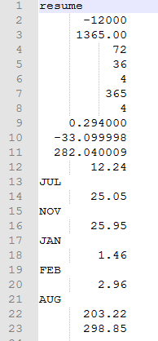

**6 – Some examples**

**EX1 :**

**CALENDAR = 1**

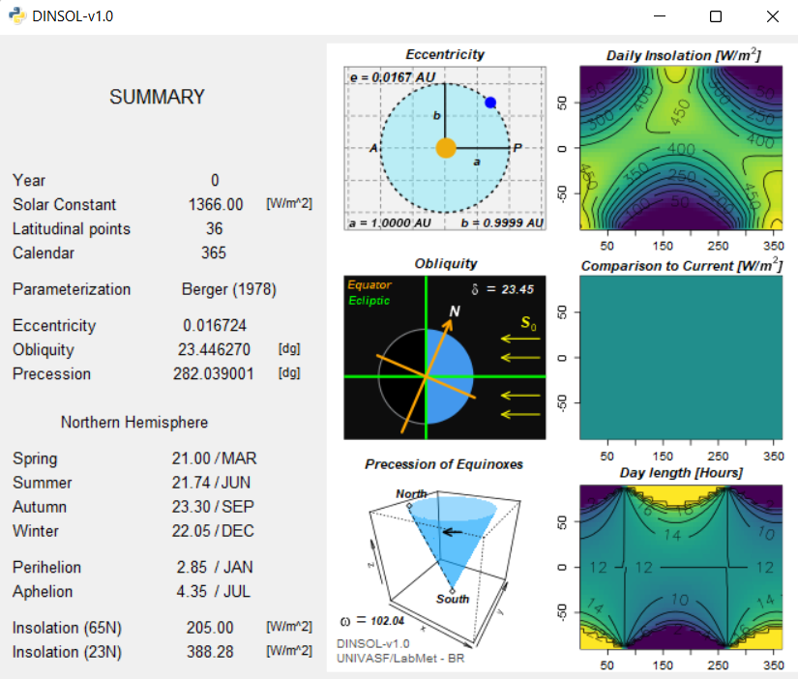

**CALENDAR = 2**

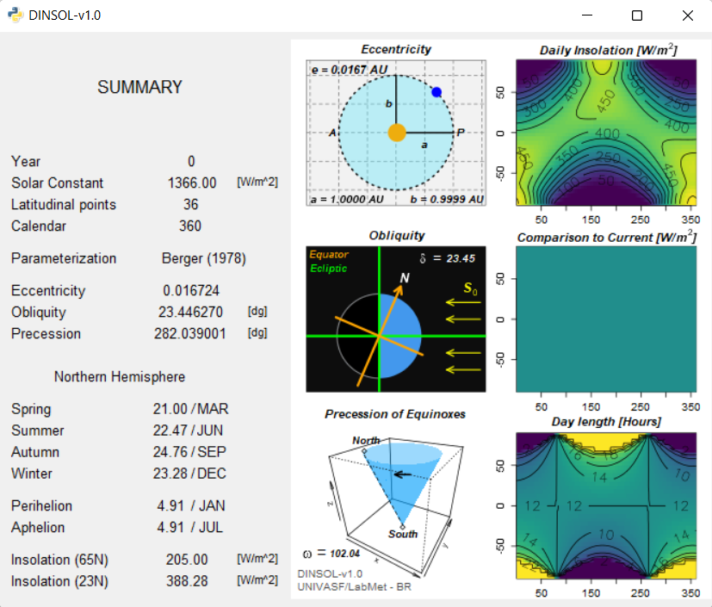

**EX2 :**

**S0 = 1366 Year = -6000**

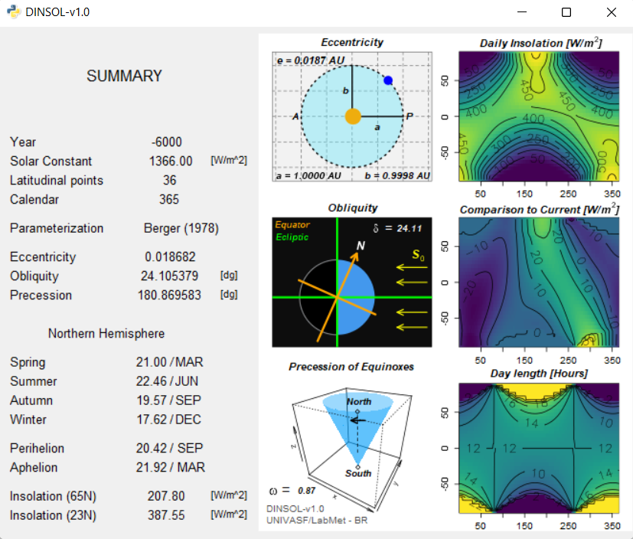

**S0 = 2500 Year = -6000**

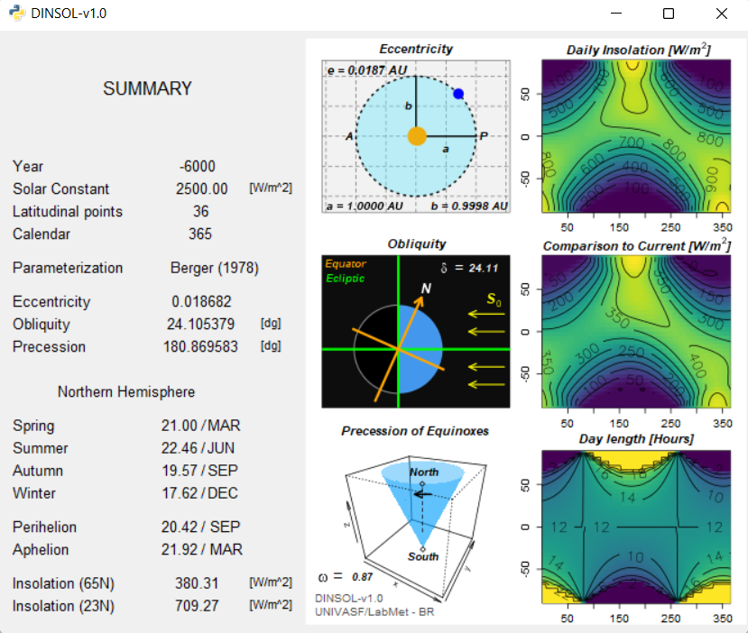

**EX3:**

**ECC = 0 User-define value**

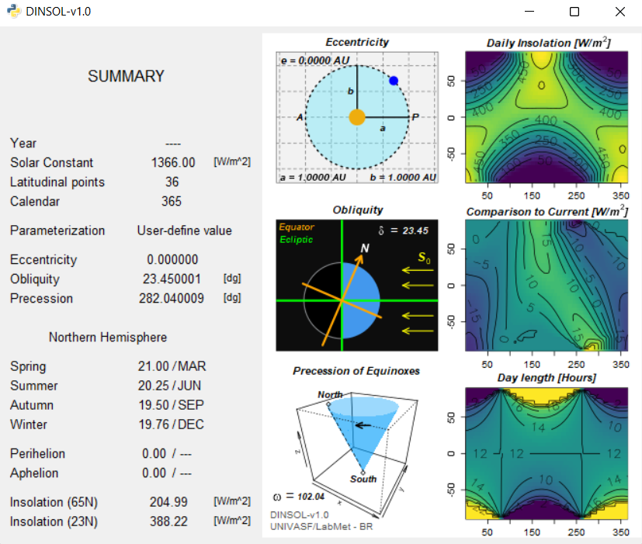

**ECC = 0.5 User-define value**

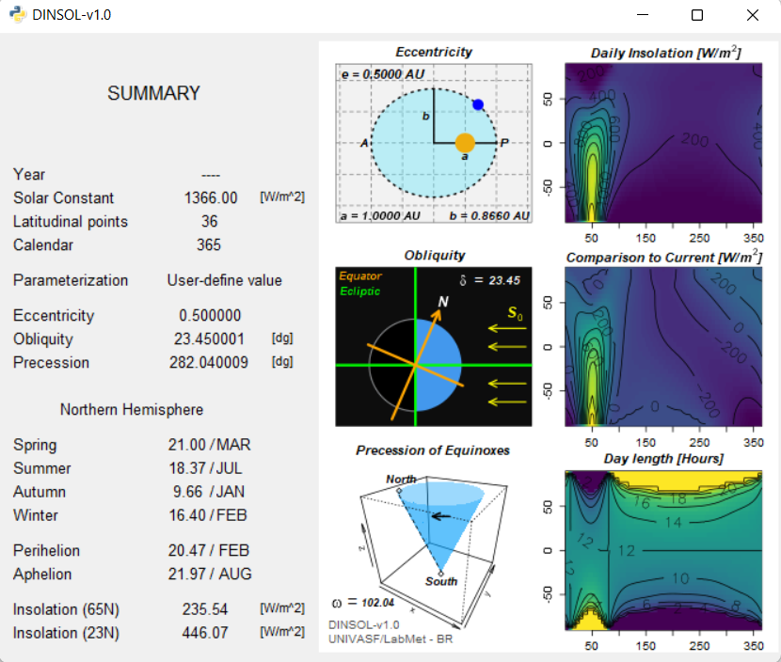

**EX4:**

**OBLQ = 0**

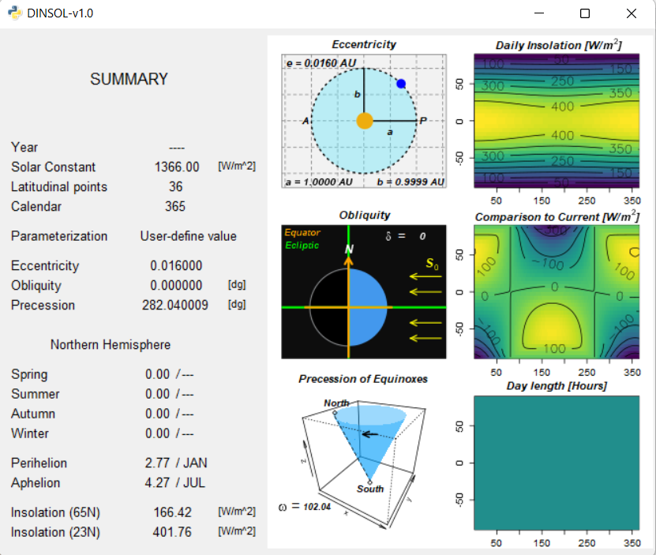

**OBLQ = -40.5**

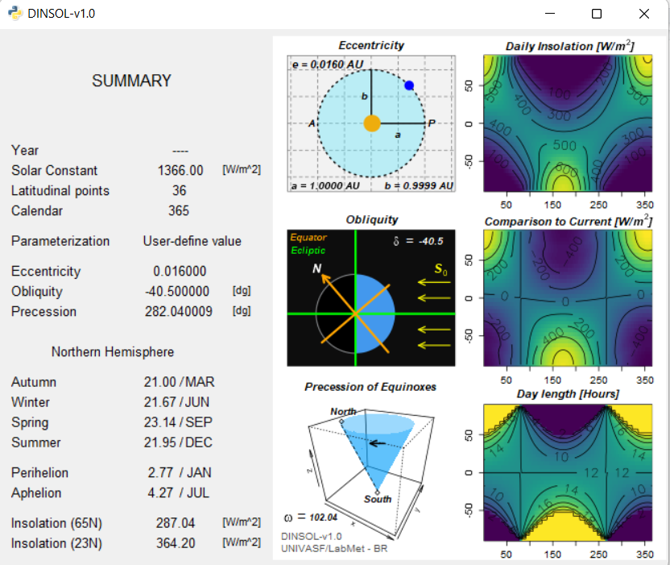

**EX5:**

**PRCS = 150.3**

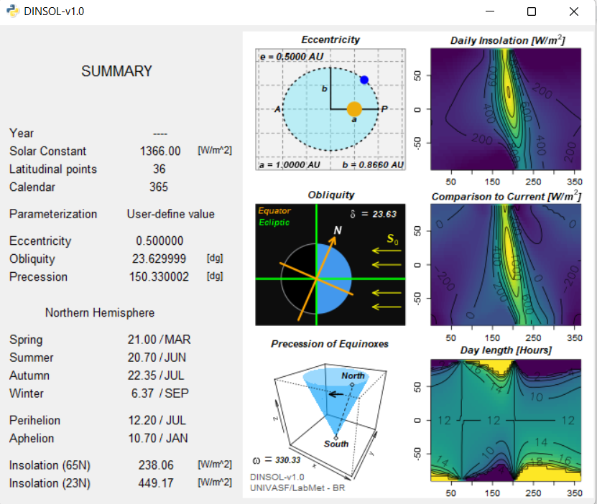

**PRCS = 341**

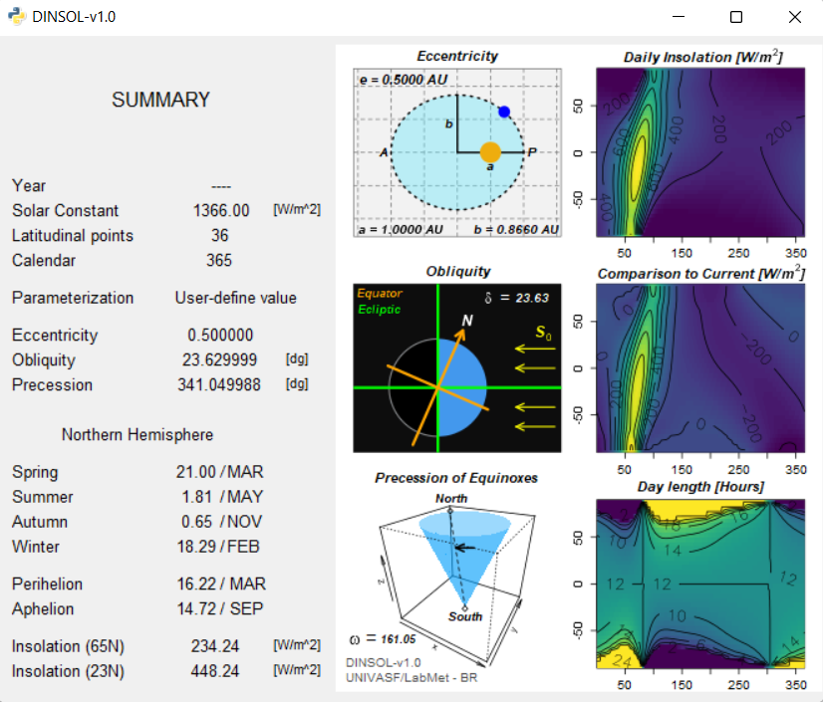

**EX6:**

**21/MAR NY=10 | res=18°**

**Latitude range [81.0°S – 81°N]**

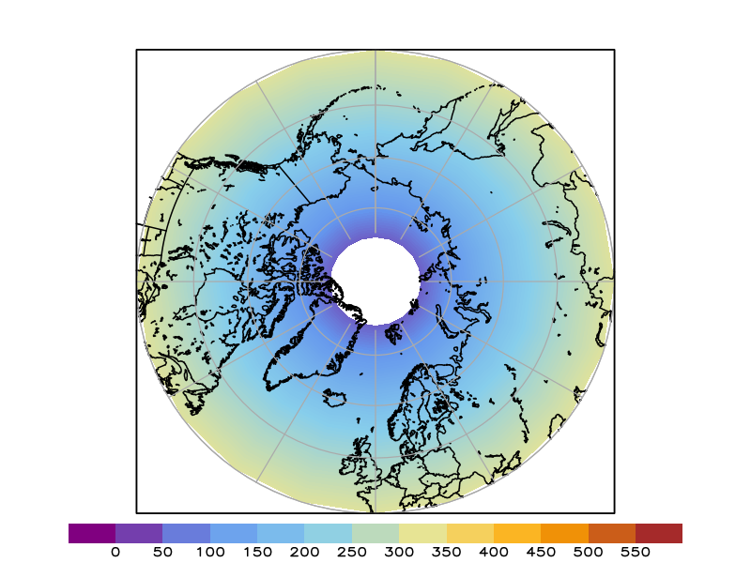

**21/MAR NY=90 | res=2°**

**Latitude range [89.0°S – 89°N]**

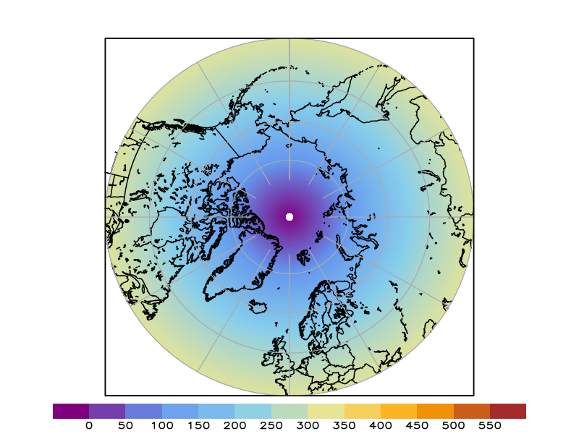

**EX7: Global Irrandiance [from binary file “radiation”]**

Global solar irradiance at the top of the atmosphere during the solstices and the September equinox.

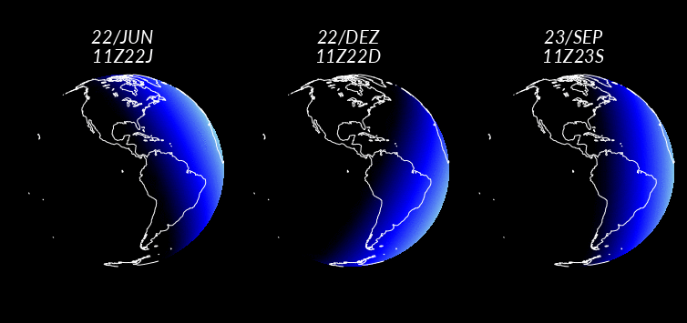

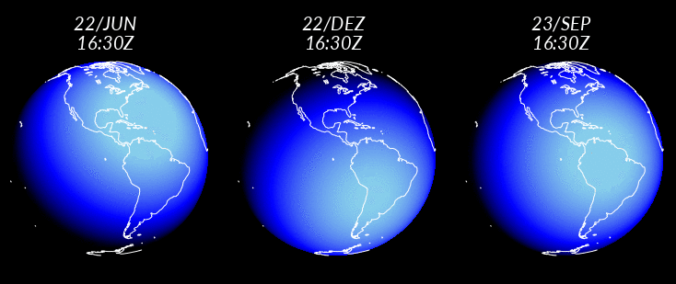

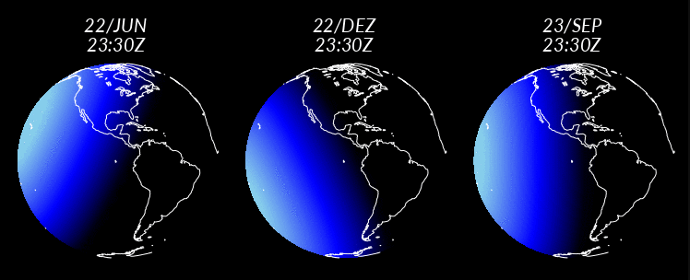

**Referências**

Berger, A. L. (1978). Long-term variations of daily insolation and Quaternary climatic changes, **J.Atmos. Sci**., 35, 2362-2367, doi:[10.1175/1520-0469(1978)035<2362:LTVODI>2.0.CO;2](D:\\Windows\\Backup_Dell_Inspiron\\h)

Berger and M.F. Loutre (1991), Insolation values for the climate of the last 10 million years, **Qua-ternary Science Reviews**, 10, 297 - 317, doi:[10.1016/0277-3791(91)90033-Q](https://www.researchgate.net/publication/223018680_Insolation_values_for_the_climate_of_the_last_10_million_years)

J. Laskar et al. (2004), A long-term numerical solution for the insolation quantities of the Earth, **Astron. Astroph.**, 428, 261-285, doi:[10.1051/0004-6361:20041335](https://www.aanda.org/articles/aa/abs/2004/46/aa1335/aa1335.html)

Laskar, J., Fienga, A., Gastineau, M., Manche, H., 2011. La2010: a new orbital solution for the long-term motion of the Earth. **Astronom. Astrophys**. 532, A89. <http://doi.org/10.1051/0004-6361/201116836>.

Michael Crucifix. R Package: **PALINSOL**

<https://www.rdocumentation.org/packages/palinsol/versions/0.93>